Curriculum-led Activities from Doctor Peter’s Good Earth Magic

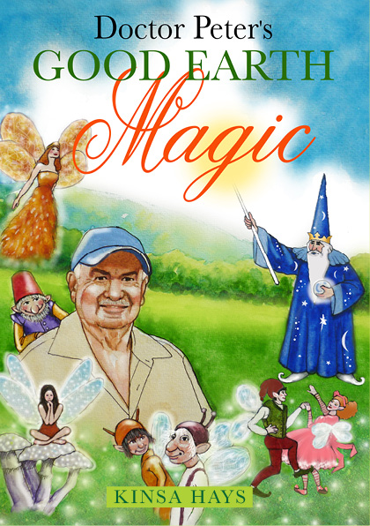

**BACKGROUND of this soil science story**

The elves in this story stand for farmers and growers struggling to understand why their animals and crops are under-performing. The method – ‘putting enough fertiliser on should do the trick’ – i.e. the sufficiency concept, isn’t working. Challenged to show humans how to replenish soil by rebalancing it as nature intended, the elves are directed to Peter Lester (also known as ‘Doctor Dirt.’) His answer: use the best mineral combination for each soil type or crop.

The kindly soil scientist shares with the elves his expertise in soil, plant and animal nutrition. He’s paid in gold, dug by the dwarves from the Waihi hills. Doctor Peter must battle the traditional methods of fertiliser application espoused by fertiliser companies and the sceptical magician, B.Warew*elf*.

Doctor Peter’s Good Earth Magic & the Science Curriculum

**USING THE BOOK IN THE CLASSROOM**

The subject of soil overlaps each of the strands in the curriculum. How the story fits in with learning objectives:

**LIVING WORLD** strand

* Understanding how living things interact with each other and the non-living environment *(i.e. soil status, plant and animal nutrition.)*
* Understanding life processes. (*i.e. life cycle of a grass grub, ragwort or California thistle.*)

**PLANET EARTH** strand

* Understand the subsystem of land and soil differences (*i.e.* *how different plants like different places; soil testing; plant nutrition.)*
* We are guardians of our finite resources (*i.e. the elves taking responsibility to do something.*)
* Understanding human impact on the soil, both positive and negative (*i.e. balancing soil, cf. sufficiency concept.)*
* Understand the interaction of soil and plant and make informed decisions (*i.e. what did the cows choose; how did Doctor Peter know what minerals to choose to balance the soil.)*

**PHYSICAL WORLD** strand

* Understanding the physical phenomena of balancing the soil (*i.e. soil nutrition.*)
* Understanding how a good soil balance in the field affected Farmer Gerry’s farm and what might happen next.

**MATERIAL WORLD** strand

* Understanding the role of chemistry in the world (*i.e. the example set for the elves to emulate; how being open to new ideas might change their farming/growing patterns.)*

**SUGGESTED ACTIVITIES BASED ON Doctor Peter’s Good Earth Magic**

**LIVING WORLD strand**

1. Investigate the life cycle of a grass grub <http://agpest.co.nz/pest-directory/#pests> and <http://agpest.co.nz/?pesttypes=grass-grub-brown-beetle-adult>
2. Investigate the life cycle of ragwort or California thistle <http://agpest.co.nz/pest-directory/#weeds>
3. Discuss what you might do to get the best from the soil to grow:

* Pasture for the farm that has a ragwort problem.
* Grassy lawns around the home with patches of brown.
* Vegetables for a kitchen garden over-run by bugs.
* What to do when your flowers for the market aren’t producing the best blossoms.

**PLANET EARTH AND BEYOND strand**

1. If we are kaitiaki – guardians of the land – how best should we look after it? (Think of how a medical doctor looks after your body when you aren’t well.)
2. In the story, what was the interaction between the soil, the plants and the cows? What happens to your body when you make healthy choices?
3. How would you improve the soil in your home garden? <https://m.wikihow.com/Improve-Soil>
4. Collect soil samples from around the district. Record the differences. You could try growing radishes in them and see the difference in the plants.

**PHYSICAL WORLD strand**

1. Doctor Peter Lester was an expert in Applied Nutrition. It is a term to emphasize the role that diet has in promoting health and as a therapy. What might happen to the food we grow when our soil is under-nourished?
2. What happens to people when they are under-nourished?
3. In the story, what was the effect on Farmer Gerry when he saw the results of balancing the mineral nourishment of the soil?

**MATERIAL WORLD strand**

1. What is a laboratory?
2. How do you take a soil sample?
3. Sketch an imaginary farm that has flat land, hills and a swamp. Indicate with a cross where you would take soil samples to send to a Laboratory.
4. Why wouldn’t you take a soil sample near a gate?
5. QLabs has developed from Peter Lester’s business. What do they do? <https://www.qlabs.co.nz/>
6. Write these mineral names and symbols separately on cards and create a card game with them:

S Sulphur P Phosphorus

Ca Calcium Mg Magnesium

K Potassium B Boron

Fe Iron Mn Manganese

Cu Copper Zn Zinc

Co Cobalt

(Additional resource: <http://education.jlab.org/itselemental/tableofelementsc.pdf>

Doctor Peter’s Good Earth Magic is available from Wheelers Books, Total Library Solutions, Academy Books. Or check out <https://www.kinsahays.com/>

**The real PETER LESTER,** who permitted me to use his name and Animal Nutrition business,passed away in August 2018. He was one-of-a-kind. He could provide a Bible quote for any growing query. His knowledge was as astonishing as the way he was disparaged for his methods. Yet they were scientific. Analysing soils from many parts of the world for their nutritional values, then matching the results with plants that liked each soil type was the reason, he was able to produce such spectacular results.



I asked, “What are the advantages of ‘balancing’ soil nutrients over the present ‘sufficiency’ method where ratios are not considered?”

His reply: “Throughout Nature’s realms she has selected specific plants that grow on specific soils under specific soil conditions. We have introduced plants into an environment where they would not have not normally grown, or else they would have already been here.

If we take a man to the moon, we take his environment with him. When we duplicate as near as practicable those sets of conditions found in a plant’s country of origin, we have fewer metabolic problems with the plant, the animal and man consuming it.

At present the planet is in panic mode where we have health issues and we are throwing money at the drug companies and medical profession with reckless abandon; the ambulance at the bottom of the cliff scenario. We are turning a blind eye to the very basis of all nutrition, the soils on which all foods/feeds depend.

We leave this to the fertiliser companies who have one target in mind: increased profits. If we don’t wake up soon, we will all be pushing up daisies.

Unfortunately, nitrate poisoning that is so rife, decreases the oxygen carrying capacity of our blood, or more correctly, its ability to supply oxygen to cells. The net result is an increase in lethargy. We just don’t care anymore.”

Peter Lester